VT STORMATER MANAGEMENT

FACT SHEET

**Managing Storage Areas for Bulk Quantities of Materials**

This fact sheet outlines best management practices for storing bulk quantities of materials, including storage techniques and erosion control practices for preventing the runoff of material from rain events.

Potential Bulk Storage Materials:

|  |  |
| --- | --- |
| * Topsoil | * Gravel |
| * Sand | * Mulch |
| * Compost | * Concrete |
| * Metal Products | * Construction Materials |

**Bulk quantities of materials should be stored:**

***Suitable for both loose and bagged materials:***

1. Under a covered area/roofed structure that prevents direct contact with rainfall, snow, and wind – ideally a 4-walled structure.
2. Under a 3-walled structure that utilizes a temporary fourth “wall” such as plastic sheeting when the area is not in use.
3. On a paved surface with a roof or covering so that no rainfall contacts the material within the storage area. Appropriate control measures should also be utilized to direct runoff around the storage area.
4. Covered with plastic sheeting secured with weights, such as cinder blocks or bricks – it is recommended to place weights uniformly over the stockpile to prevent shifting and exposure.

***Suitable for only bagged materials:***

1. On a paved surface that slopes to minimize water pooling. Materials should be stored on an elevated surface, such as pallets, to avoid the potential for direct contact with runoff.

**General Best Management Practices:**

**Avoid storing bulk quantities of materials:**

* Within 300 feet of any well used for drinking, irrigation, or industrial water supply.
* Within 100 feet of features that have the capability to serve as a pathway for runoff to channelize such as storm drains and ditches.
* Within the 100-year floodplain of a stream or within 300 feet of a stream, river, lake, pond, or wetland.

**Other considerations:**

* Consider piling the material in a non-conical shape to improve loading efficiency. Radial/kidney or sugarloaf-shaped piles are easier to cover with a flexible material. *See Figure 1.*
* When utilizing a portion of the stockpile, remove only a section of the protective covering so as to prevent moisture absorption and minimize exposure to precipitation.

**NOTE:**

**If a bulk storage area causes significant runoff, contact Environmental Health and Safety at (540) 231-3600.**

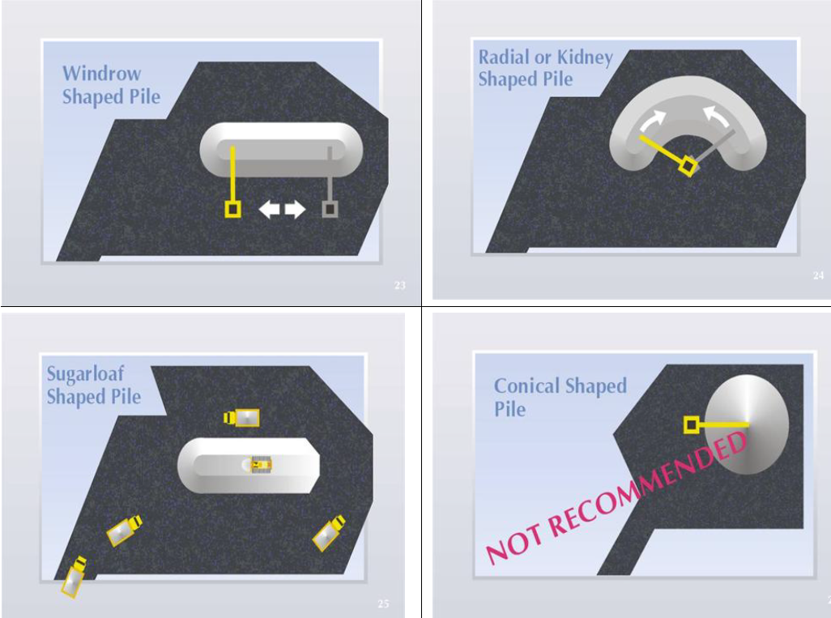

**Figure 1:** Outdoor Stockpile Shapes

(Yellow and gray lines denote access points to the stockpile.)